Democratic and People’s Republic of Algeria
Ministry of Higher Education and Scientific Research

Université M'Hamed Bougara Boumerdes
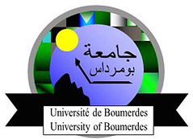
Faculty of Sciences
Department of ………

Field: ……………
Sector:…………….

Course Handout
(Entitled)

Carried out by:
First name and last name……………. (Rank)

This handout is intended for students enrolled in Licence (L1/L2 or L3) /Master (M1/M2) Specialty…

20../20..

